**Order your Personalized Apprentice Builders Hoodie Now! $45 Each**

**ALL Orders are PREPAY ONLY through the Company Store located in Bldg #1919**

(Open Monday – Thursday 11:30am-1:30pm and 2:30pm-4:30pm. Closed Friday.) Email completed form to companystore@as.edu

**Order No Later than THURSDAY, OCTOBER 5, 2023. No Returns/Exchanges.**

NAME: ____________________________________

MOBILE NUMBER: ________________________________

EMAIL: _____________________________________

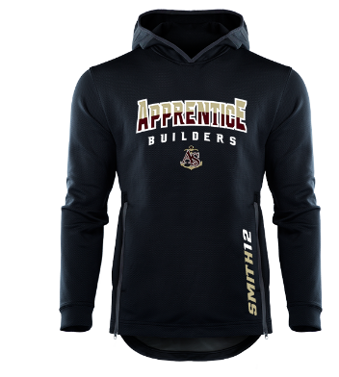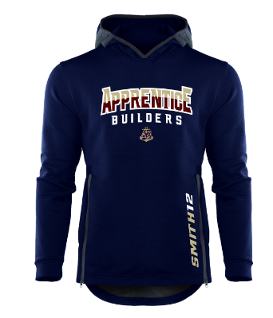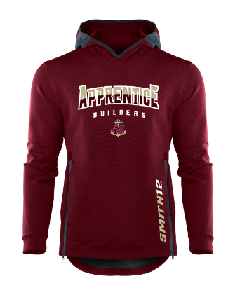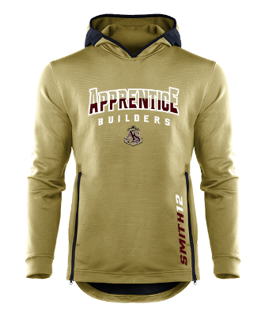

Specify Color Selection: Black; Navy; Maroon; Vegas Gold

Specify Size: Extra Small; Small; Medium; Large; Extra Large; Double Extra Large; Triple Extra Large; Four Extra Large

Personalization available up to 14 Characters:

Specify Color Selection: Black; Navy; Maroon; Vegas Gold

Specify Size: Extra Small; Small; Medium; Large; Extra Large; Double Extra Large; Triple Extra Large; Four Extra Large

Personalization available up to 14 Characters:

Specify Color Selection: Black; Navy; Maroon; Vegas Gold

Specify Size: Extra Small; Small; Medium; Large; Extra Large; Double Extra Large; Triple Extra Large; Four Extra Large

Personalization available up to 14 Characters:

Specify Color Selection: Black; Navy; Maroon; Vegas Gold

Specify Size: Extra Small; Small; Medium; Large; Extra Large; Double Extra Large; Triple Extra Large; Four Extra Large

Personalization available up to 14 Characters:

STORE VERIFICATION:

DATE PAID: AMOUNT PAID: RECEIPT NUMBER: