Order your AS or NNS Carhartt ® Jacket today! $130 EACH
ALL Orders are PREPAY ONLY through the Company Store located in Bldg #1919
(Open Monday – Thursday 11:30am-1:00pm and 2:30pm-4:30pm. Closed Friday.)
Fill out at The Company Store or email completed form to companystore@as.edu

Order No Later than THURSDAY, NOVEMBER 30, 2023. No Returns/Exchanges.
NAME: ____________________________
MOBILE NUMBER: _____________________
EMAIL: ____________________________

Carhartt ® Quilted-Flannel-Lined Duck Active Jac (CSTJ140)
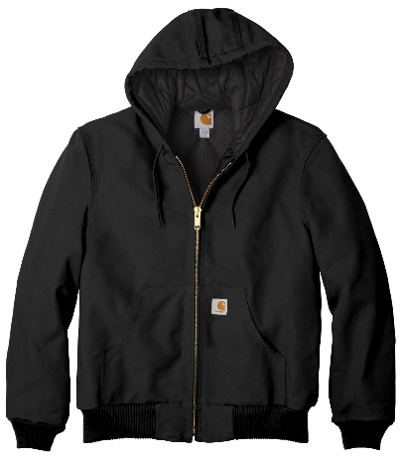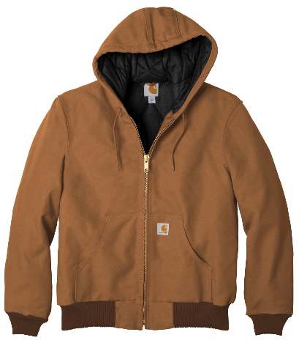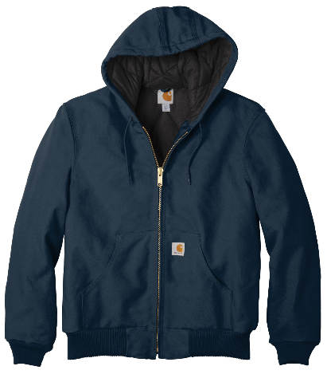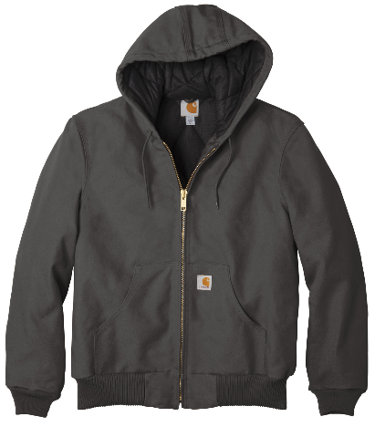
Specify Logo Selection: AS logo; NNS logo
Specify Color Selection: Black; Carhartt Brown; Deep Navy; Gravel
Specify Size: Small; Medium; Large; Extra Large; Double Extra Large; Triple Extra Large; Four Extra Large; Five Extra Large

STORE VERIFICATION:
DATE PAID: AMOUNT PAID: RECEIPT NUMBER:

